**Sri Lanka Institute of Information Technology**

Milestone 2

**User Experience Engineering – IT3050**

B.Sc. (Hons) in Information Technology

Group: SER026_WEEKEND

Sustainable Development Goal: Life Below Water

|  |  |
| --- | --- |
| **Student ID** | **Student Name** |
| IT20281564 | M.T Sanju |
| IT20039004 | H.C Liyanage |
| IT20047542 | W.M.K.K.B Walisundara |
| IT20206550 | K.I.K.R.D.N. Kandakkulama |

# Introduction

Healthy oceans and seas are essential to our existence. They cover 70 percent of our planet, and we rely on them for food, energy, and water. They are the most diverse and important ecosystem, contributing to global and regional elemental cycling, and regulating the climate.

Under the sustainable development goals specified by the United Nations, we choose life below water as the sustainable development goal.

For that we are going to develop a research publishing app mainly for the people who interacting with the oceans and seas to aware to co-exist with the ocean life and how to use the oceans, seas, and marine resources for sustainable development.

We identified 04 stakeholders for this project such as:

1. Researcher
2. Diver
3. Sponsor
4. Aquarist

**IT20206550**

For my persona aquarist,

I use goal as, how aquarist know where the best sea organisms are and how they give publicity to their aquarium.

**IT20039004**

For my persona researcher,

I use my goal as conservation of coastal ecosystems.

**IT20047542**

For my persona diver,

I use goal as uplifting divers who dive as a profession.

**IT20281564**

For my persona sponsor,

I use goal as reduce the carbon footprint in the seas and oceans.

# User Research Questions

**IT20206550**

How to provide publicity for the aquariums?

How are the interested in this job field?

How they come up with the problems, that aquarist facing when working with under water?

How they know peoples who are willing to help their aquarium?

How they know places to find rare sea organism and seaweeds?

**IT20039004**

How to handout marine knowledge among readers?

How to interact the people who are interested in research?

How to identify the ideal problem for research?

How to solve the cause of the root by the research?

How does the research benefit the conservation of the costal environment?

**IT20047542**

How satisfied are professional divers with their career?

How can professional divers get publicity for the service they provide?

How divers provide service for their consumers?

How can they get knowledge about new diving techniques and equipment?

How does the environmental damage related to oceans and seas affect them?

**IT20281564**

How to find the main causes of the carbon footprint in oceans and seas?

How it effects the carbon footprint in water?

How it affects the whole ecosystem and the biodiversity?

How to minimize the carbon footprint in the oceans and the seas?

What are the advantages we can get by reducing the carbon footprint in oceans and seas?

# Methodology

The user research has been done through Interviewing, Video recording of the interviews and questionnaire related to the selected persona and the goal. A mobile device and an internet connection were equipped to conduct the user research successfully.

**Interviewing**

* The interview was conducted in a question-and-answer format. We have selected two users and interviewed them. We have selected their homes as the location due to this pandemic situation through the online platforms.

**Video recording**

* The interview meetings were conducted via Microsoft Teams and recorded.

**Questionnaire**

* Questionnaire has been conducted using a google form during our user research period. We shared the google form link through the WhatsApp groups and gathered responses from the users and collect their opinions according to their user experience.

## Interviewing

**IT20206550 – Script for aquarist**

Through MS Teams, four one-on-one interviews were done, covering every function. Both closed- and open-ended questions were included in the previously prepared questions.

Introduce myself and application.

1. Have you ever used any application about ocean and seas before?

If "yes", ask what those applications are and was there any difficulties using it.

Show the user flow diagram of adding comment and explain it ask questions while presenting

1. Do you understand the flow of the functionality?

If "No", Explain about the function “Adding comment”

1. Is there anything you need to add to this adding comment function?

If “yes”, what is it

1. Is there anything you need to change in the functionality?

If “yes”, what is it

1. Is this useful for aquarist to have this function in this app?

If “No”, Which kind of function will be useful for you

**Demographic Questions – Part A**

1. Gender

|  |  |  |
| --- | --- | --- |
| 1.1 | Male |  |
| 1.2 | Female |  |

1. Age

|  |  |  |
| --- | --- | --- |
| 2.1 | Below 18 |  |
| 2.2 | 19-29 years |  |
| 2.3 | 30-40 years |  |
| 2.4 | 41-51 years |  |
| 2.5 | Above 52 years |  |

**Part B**

1. Economic contribution and awareness of the people about aquarium and aquarists.

|  |  |  |  |  |  |  |
| --- | --- | --- | --- | --- | --- | --- |
| **No** | **Question** | **Strongly agree (5)** | **Agree (4)** | **Neutral (3)** | **Strongly disagree (2)** | **Disagree (1)** |
| **Economic** | | | | | | |
| 3.1 | Aquarium development motivates local Entrepreneurship development in coastal areas. |  |  |  |  |  |
| 3.2 | Does government provide reasonable funds |  |  |  |  |  |
| 3.3 | Does people are willing to visit your aquarium |  |  |  |  |  |
| 3.4 | There are people who are willing to support aquarium |  |  |  |  |  |
| **Awareness** | | | | | | |
| 3.5 | Mobile app is useful for publicity more than website |  |  |  |  |  |
| 3.6 | Blog writing is more efficient than writing articles to newspapers to take a publicity |  |  |  |  |  |
| 3.7 | Using mobile app is easy to read research papers about newly found sea organism |  |  |  |  |  |
| 3.8 | Using mobile app, it is easy to share your knowledge about sea organism |  |  |  |  |  |
| 3.9 | This mobile app helps to peoples to get to know more details about aquariums and sea organism |  |  |  |  |  |

1. Is there any suggestion from your side?

**IT20039004 – Script for Researcher**

I begin the introduction by presenting myself and describing the goal of the research and the mobile application.

Part A- Demographic Questions

1. What is your age?
2. What brings you here?
3. What is your goal of doing research?

Part B

1. What is your point of doing research?
2. What are the difficulties you faced as a researcher and how did you overcome them?
3. Do you think this app will be a helpful medium to researchers to publish their work?
4. What do you think about life below water?
5. Do you think an app like this will help people to coexist with the costal eco system?
6. Do you think an app like this will affect the livelihood in the costal environment?
7. According to you what are the threats towards marine life?
8. According to your knowledge what are suggestions to protect life underneath water?
9. Tell me your suggestion to improve research underwater without divers?
10. If you are doing research in life below water what will be your goal?

**IT20047542 – Script for Diver**

I begin by introducing myself and explaining the research publishing application.

Part A- Demographic Questions

1. What is your age?
2. Where are you currently living?
3. What is the goal of your diving?

Part B

1. How did you start interested in diving?
2. What kinds of difficulties do you now experience as a diver?
3. What is your initial reaction to our mobile application?
4. Do you think that researchers can get a publication for the service of divers by doing research and publicize through this app?
5. Do you believe that you can get a solution by presenting the various problems of divers through this application?
6. Do you think is this application important to share knowledge about diving?
7. Do you think other divers would like to share knowledge problems through this?
8. How would you support researchers doing research on ocean and sea divers?
9. What do you think about the opportunity to raise your questions through comments?
10. Would divers like to submit their problems publicly through this app?
11. What kind of problems will divers face if only English language is used to Publicite research?
12. What are the suggestions for developing this mobile application on your side?

**IT20281564 – Script for Sponsor**

Part A - Demographic Questions

Question 1 - What is your age?

Question 2 - Where are you from?

Part B

Question 1 - What is the first impression when you see the sea and the oceans?

Answer – Its beautiful outside but when it comes to inside its polluted.

Question 2 – According to you what is the main cause for this issue?

Answer – Its because the carbon footprint. So, to protect the biodiversity, we need to protect the oceans and seas. Because it is the place where 70% of oxygen is generated. Furthermore, we need to reduce the carbon footprint.

Question 3 – Are you satisfied with the current steps that have been implemented to reduce the carbon footprint?

Answer – No, because there are so many international rules, but no one is following it and we can’t find a proper governing body. Furthermore, we need to add more international rules and regulations.

Question 4 – What are the projects we can implement to reduce the carbon footprint?

Answer – Well, it’s a large-scale project and we can’t do it alone. But according to our capacity we can do a coral reef restoration project.

Question 5 – We are planning to do a coral reef restoration project. Can you invest on our project and be our sponsor?

Answer – Yeah sure. And I have few more sponsors as well we can get their contribution as well.

Question 6 – Do you think this project will create a big difference in the eco system?

Answer – Yes. Every journey starts with a single step and this will create a huge impact

Question 7 – Does this project has any legal obligations or any protocol we need to follow before we start the project?

Answer – Yes, we need to contact environment authority and obtain the necessary permissions and advice.

Question 8 – How long will it to take to complete the project?

Answer – It will take about one year and the return on the project is huge and can obtain the return for about 200 years.

## video recording

Link - [Milestone2_InterviewVideos](https://mysliit-my.sharepoint.com/:f:/g/personal/it20281564_my_sliit_lk/EtbKBfeF_UpEp5iqGS741PYBvnYJqzN-02bMogcs70pL6g?e=sFy7j2)

## Questionnaire

**IT20206550**

For the questionnaire I used a G-form to cover up my goal.

Link - <https://forms.gle/kcQUWUGjH1XEHdWq6>

We mainly use blog to give an awareness and publicity to the people who are interested in oceans and sea. From the aquarist response we came up that is good to use blog mobile app to give best publicity to this field. I send this form to 30 aquarists to get a correct idea about their favors. Here is the screenshots of those response.

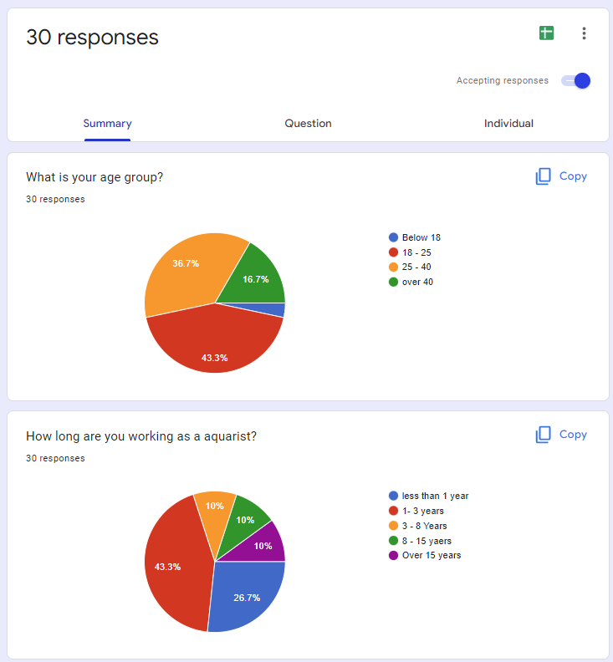

In Here I only focus on the people who are working at an aquarium or who are owner of aquarium.

I took the response using the people who have an experience in this fields. So it’s give accurate result what they are willing.

First, I focus on the issues that they have those days. Lot of them have economic issue and government support. In their comment they can’t find sponsors. And they don’t know pest places to find seaweed and sea organism. They have no platform to over come from those problems.

This is the method that those aquarists willing to find where sea organisms are. Most of them like to have a mobile app which has blogs of other people wrote. So, we came up with this blog and research paper uploading app.

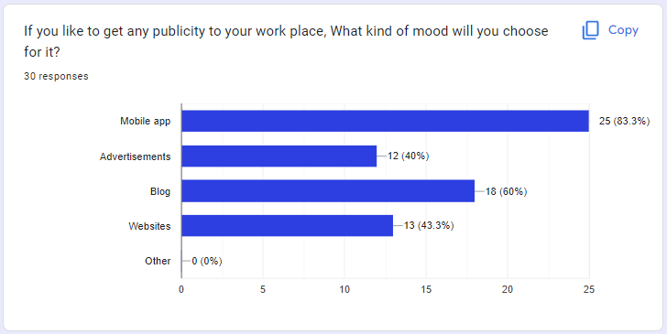

Those aquarists mainly said that they want a best publicity to their aquarium. But they don’t have platform to publicity only aquarium. So, most of aquarist are willing for platform as a mobile app and the blog writing.

Here are the functions that they suggest to our mobile app. And what are the features that they like to have.

**IT20039004**

For the questionnaire I used a G-form to cover up my goal.

Link - <https://forms.gle/K3fJ3HQqXxWZf8oJ6>

I conducted this survey in order to collect data that required to achieve the target gathering information of people who are interested in research of life underneath water. Answers from questionnaire are favorable for our application.

In here we can see age group of the people who interest in research life below water.

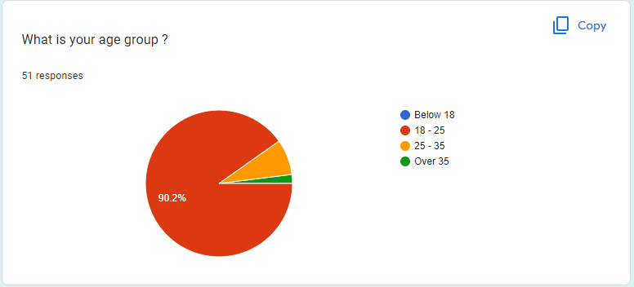

In here we can see the profession of the people who interest in Life below water.

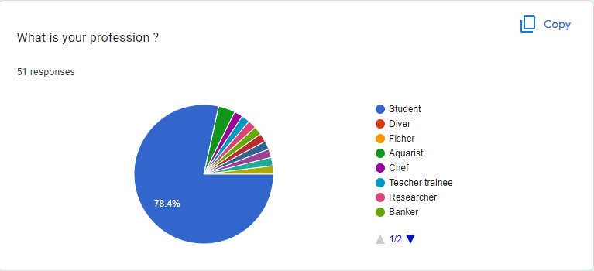

In here majority of people like to read/write articles/research about life underneath water.

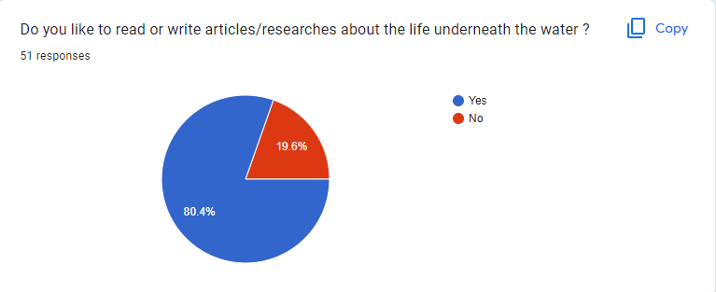

In here they have justify their reason to write or read articles/research in above question.

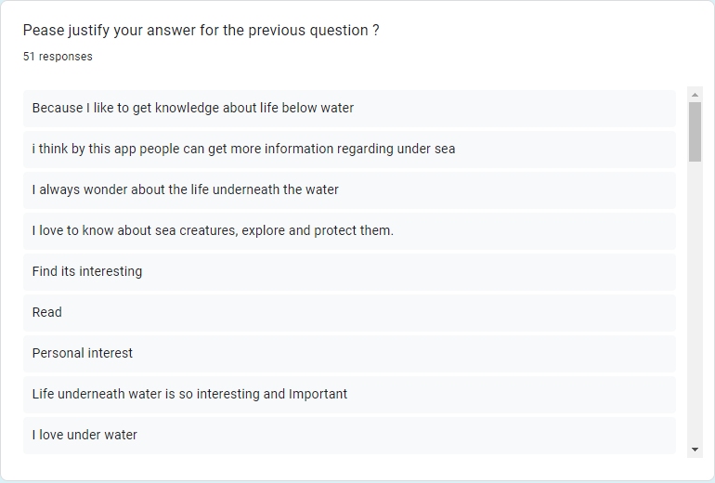

In here majority of people never came across a project like this before. Proof is given below.

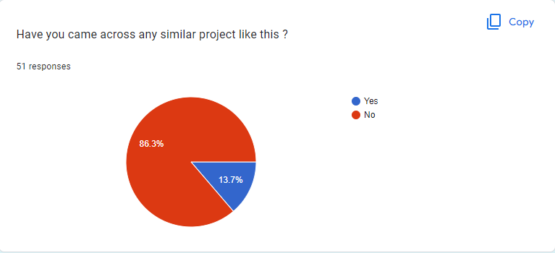

According to most people this app will be help to the life below water.

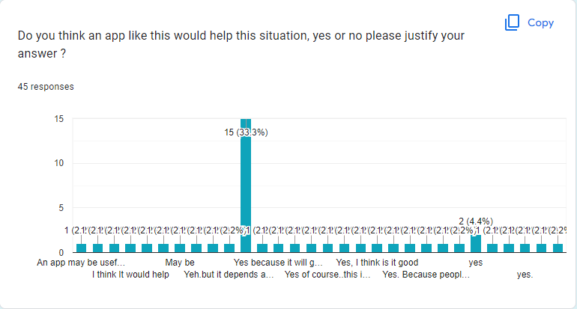

Most of the people preferred language for the articles/research is shown below.

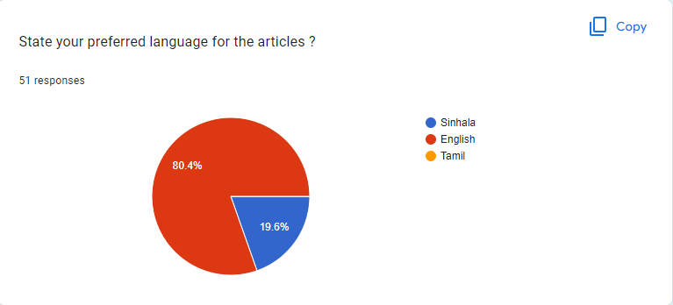

According to the majority of people this project would help to improve livelihood in the coastal area.

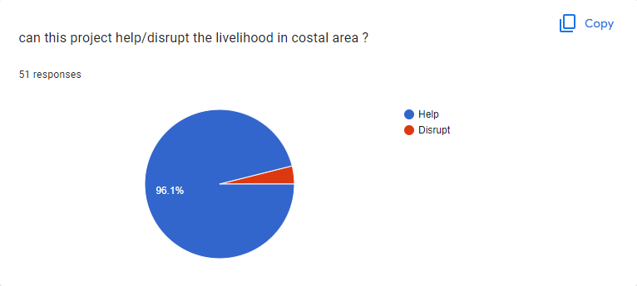

And also, they have justified their answer in here for the previous question.

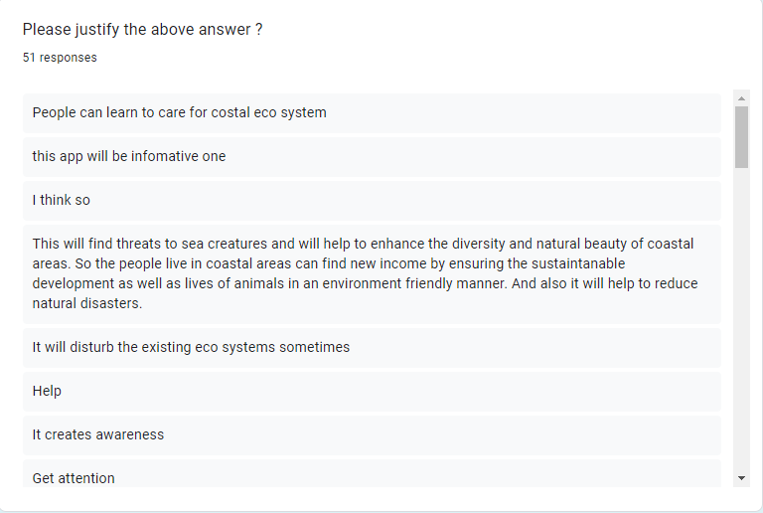

According to majority of people mostly negative impact toward the costal ecosystem is “All” option.

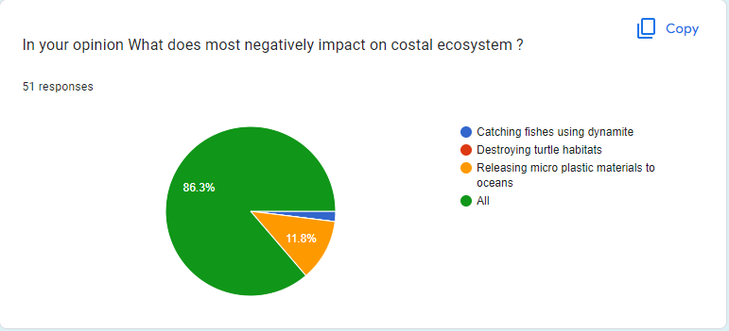

In here these are the suggestions from the contributors towards the development of the mobile app and most of their answer is “No” and “Let other researches to sign in to app and also let them to publish their work”.

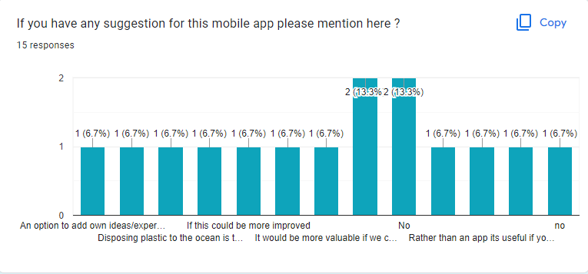

**IT20047542**

For the questionnaire I used a G-form to cover up my goal.

Link - <https://forms.gle/pBHmYhJYtzSnaDWXA>

I distributed the questionnaire to many individuals in order to gather the data required to achieve the goal of uplifting divers who dive as a profession. Most of those who answered the questionnaire are interested in diving.

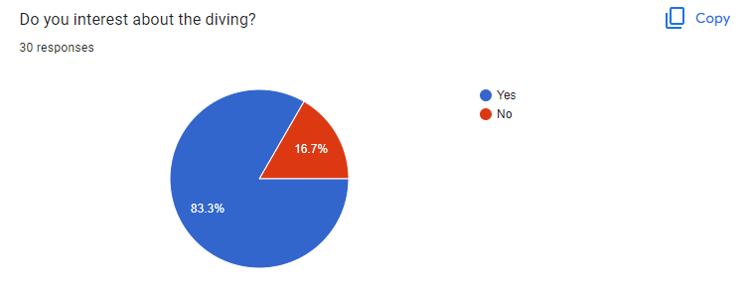

From the responses we can get an idea of what purpose the divers are diving for. Here we can see a considerable number of people diving. Doing it as a profession.

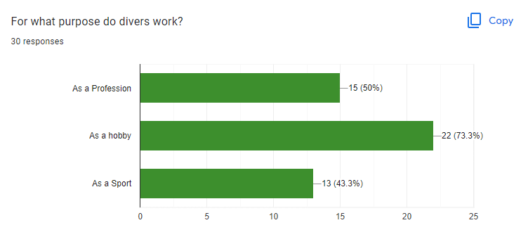

The majority opinion of the respondents is that the current professional divers are not satisfied with their career. It can have various reasons. When we asked the reasons from the respondents, they gave various reasons.

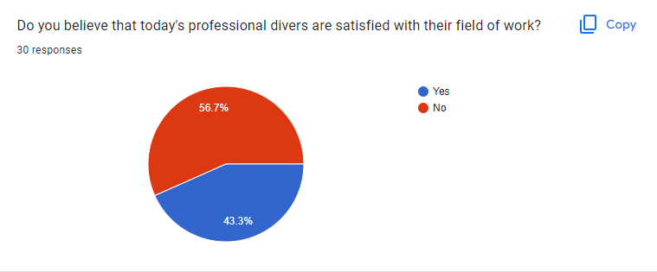

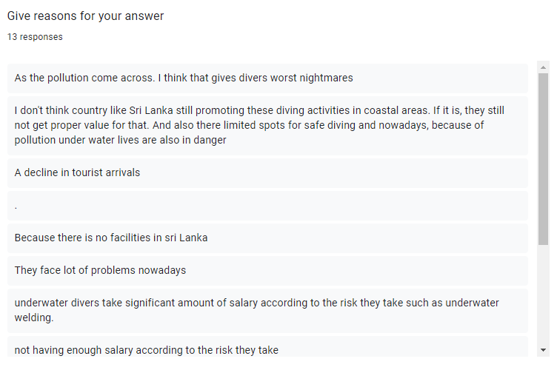

Many respondents believe that many professional divers will leave their jobs today. Various reasons have been presented for that. In addition, the responders have provided solutions to the issues.

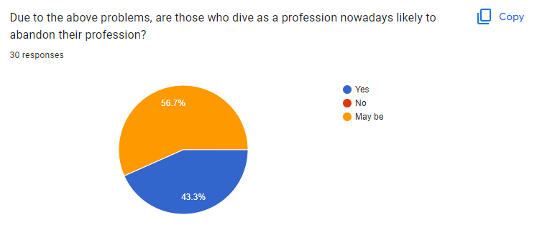

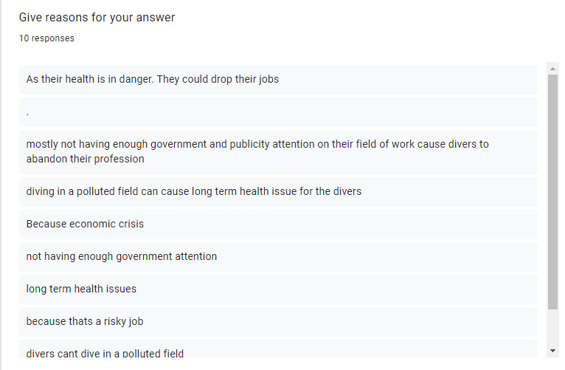

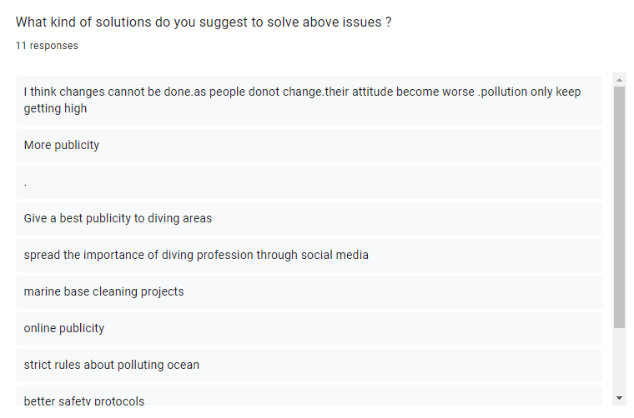

When we categorized the problems faced by professional divers and asked from responders, we got different responses.

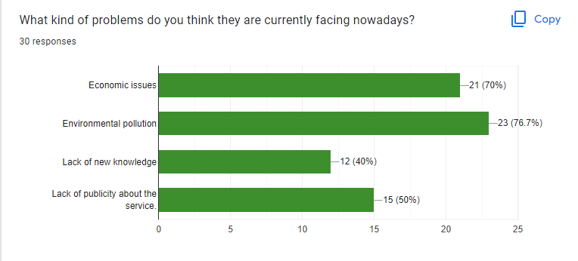

Many respondents are of the opinion that using a mobile application to find solutions to the above questions is effective. And we asked the reasons for the no or may be answers.

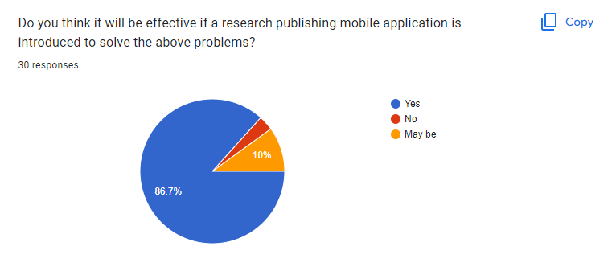

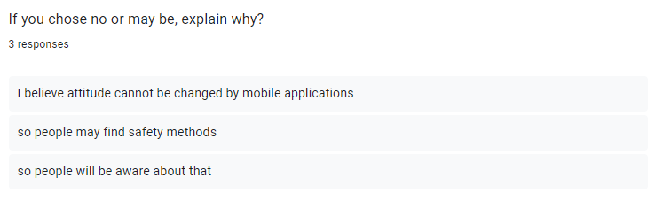

Then we asked for information about the solutions that can be provided through our mobile application for these categorized problems.

Firstly, we asked the respondents whether it is possible to give a publication to professional divers through the mobile application. Here, the answer of many people was yes. We believe that the researchers who publish research through the mobile application can make people aware of the services provided by professional divers. And we believe that we will be able to create a desire for diving in people's minds.

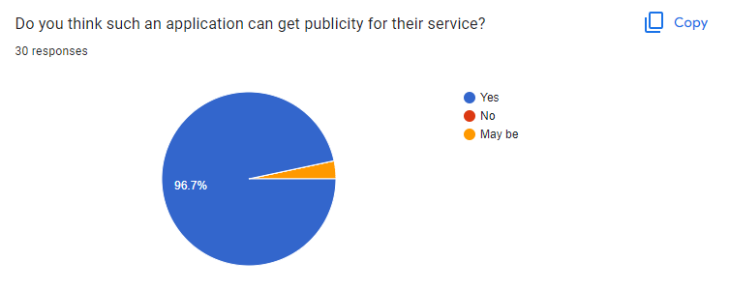

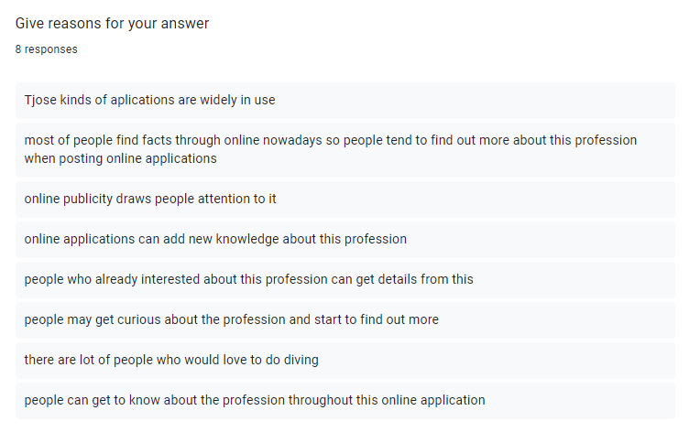

Then we asked whether the mobile application could answer the lack of knowledge of professional divers about the new technology related to diving. No one answered no. Research papers are a great source to discover new knowledge. This makes it clear that we can find a solution to this problem through the mobile application.

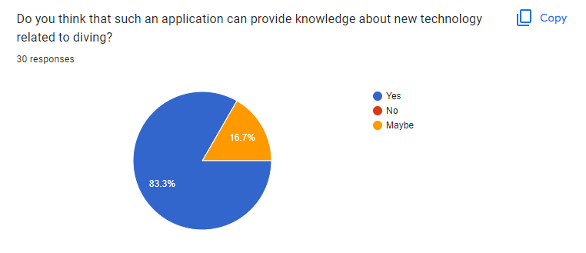

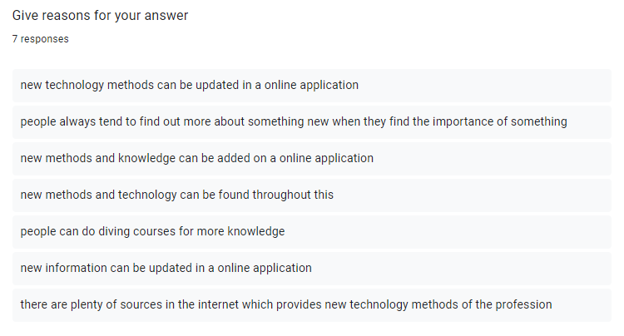

Then we asked whether the application could provide a solution to the economic problems of professional divers. We mostly got the answer "may be". But divers who have financial difficulties can get help from sponsors. Because sponsors can see divers' problems when divers comment on researchers.

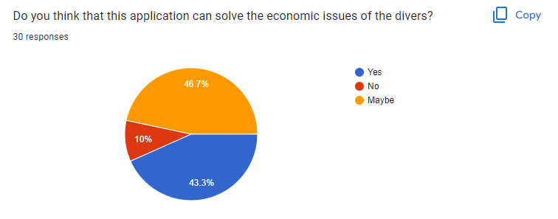

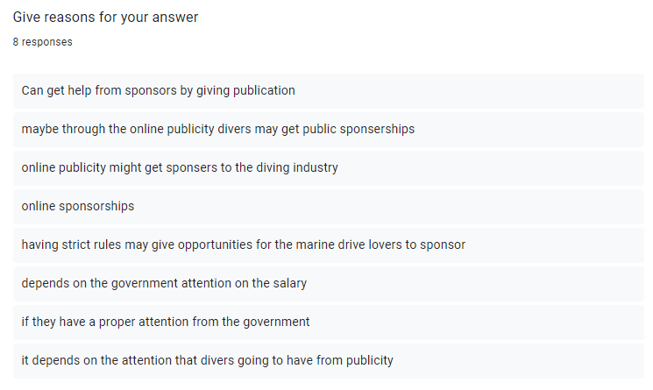

Environmental pollution done by people knowingly or unknowingly is a serious challenge for professional divers. Many people believe that this mobile application can solve it. Through research papers, people can be made aware of the impact of environmental pollution related to oceans and seas on divers and a solution to that problem can also be found.

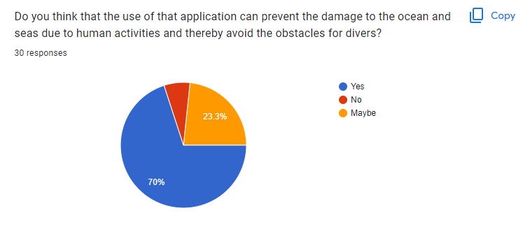

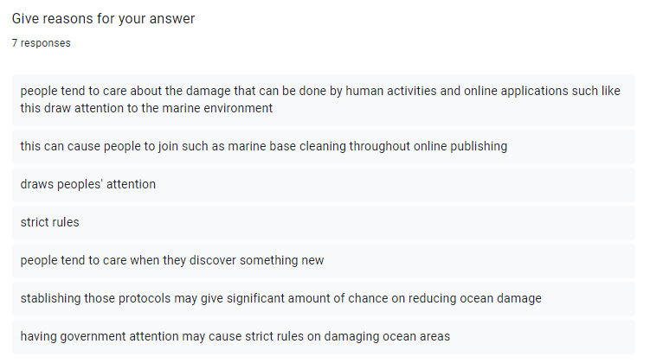

Finally, we asked the respondents' opinions to develop this mobile application.

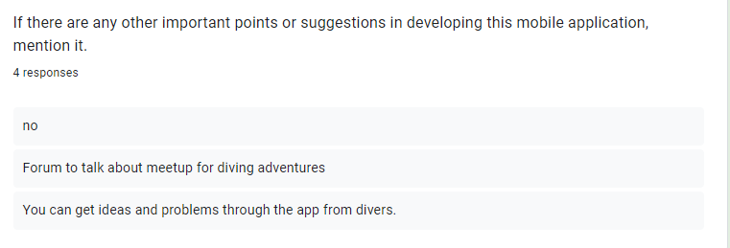

**IT20281564**

For the questionnaire I used a G-form to cover up my goal.

Link - <https://forms.gle/jAdJWc4VTSWYnhb29>

Most of the people who are interacting with the seas and oceans are in between 18-35 years old. So, we can clearly state that the young crowd of the nation is engage in this sector.

We can clearly see that more than 90% of the youngsters are not engage in clubs. We need to create awareness about the environmental clubs and the societies.

Most of the youngsters are thinking that life below water is in danger and they suggest the above methods to diversify the risks.

About 60% of the youngsters specify that they can reduce the carbon footprint in oceans and seas. This is a very good response.

But the challenge is 73% of the youngsters are seeking for the professional assistance to educate themselves to reduce the carbon footprint in oceans and seas.

Most of the youngsters suggested that a mobile application will create the necessary awareness among the youngsters.

According to this response we can clearly see that there is no app available to create the awareness. So, we decided to build a mobile application.

# Participant Profiles

|  |  |  |
| --- | --- | --- |
| Name | Demography | Location, Date and Time |
| Malshi | Age – 26  Gender - Female  Occupation – Owner of aquarium  Location - Moratuwa | Location - Online  Date - 2022 Sep 25 |
| Ryju Dilna | Age – 31  Occupation – Project Sponsor  Location – Sri Lanka | Location - Online  Date - 2022 Sep 27 |
| G.S.K.N.D.S Kumara | Age – 25  Gender- Male  Occupation – Sailor and Diver  Location- Sri Lanka | Location- At a physical location  Date – 2022 Sep 26 |
| W. Hasini Wijewardhana | Age – 23  Gender – Female  Occupation - Medical Student- Award winner at ICYS (International Conference of Young Scientists)  Location- Galle | Location - Online  Date - 2022 Sep 26 |

## Protocol

**IT20206550**

For the interview purpose I selected the team’s platform and recorded using its in built feature. I asked to interviewer to share some photos and videos of their aquarium. I prepared some wire frame to show my interviewer to get her opinion about my function add comments. And asked what I should change in this UI.

And I prepared the statistic report about response of G-form. And show them to her what is her opinion about our mobile app. And asked from her that is she agreeing with the result of this survey. And does she also accept features in our app. Are those things useful for aquarist.

I prepared some videos on adding comments to a blog. And share it with the interviewer and get her opinion about them.

Then I got permission to record the video of interview. And I request for appointment from him to do the interview.

**IT20039004**

I chose the team's platform for interview purposes and recorded using its in-built functionality. It's an internet service. Because of the distance, we prefer the internet platform to the actual platform. Google forms are utilized for data collection. Because it creates useful reports, which are extremely beneficial for analysis and interpretation

Then I obtained permission to videotape the interview. Later, she and I arranged a time for the interview.

**IT20047542**

I chose a physical location for this interview. Because the interviewer is more interested to do the interview in physically.

Firstly, I asked about his profession. Then He said that he is a sailor and diver. Then I explained about our mobile application and about the interview. I showed the report of collected data using G-form and using that I gave good idea about the application.

Then I got permission to record the video of interview. Later, I made an appointment with him to do the interview.

**IT20281564**

For the interview purpose we selected the team’s platform and recorded using its in built feature. It’s an online platform. The reason. we select online platform over the physical platform is because of the distance.

For the data collection process google forms are used. because it generates useful reports, and these reports are very useful for the analysis and interpretation.

Then I got permission to record the video of the interview. Later, we set up a time to conduct the interview.